MINISTRY OF EDUCATION AND VOCATIONAL TRAINING
ILBORU SECONDARY SCHOOL
F.IV PRE MOCK 2009
Time :………
SECTION A
Answer all questions

1 (a) Factorize completely
(i)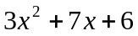
(ii) 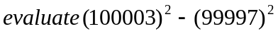
- Express 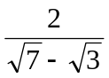with a rational denomination
(b) (i) Simplify 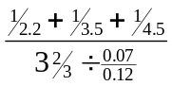
(ii) calculate the sum of interior angles of a regular octagon

2. (a) Find the coordinates of the point o n the line presented by 2x-3y+7 = 0
which is equidistant from points p(-4,-80 and Q (7,-1)
(b) Use tables to evaluate 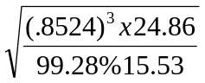

3. (a) Solve the equations 2x³ -6x+4x²y-2x²y-4xy²=0, and x - y- 2 = 0
(b) The area of a regular hexagon inscribed in a circle is 720m², find the
radius of the circle
(c) If 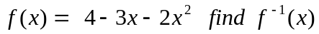

4. (a) Find the remainder when 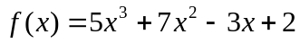 is divided by ( x – 3)
(b) Kuchi received 4000Tsh. From his father, he spent the money as follows
40% to buy soda, 20% to buy exercise books and 5% of the left to buy sugar in simplified from find the fraction of money left.
- Three forces F1=3i + 4j, F2 =5i -2j and F3 = 4i + 3j measured in Newton act at point P (0,0).
(i) Determine the magnitude and direction of their resultant
(ii) Find the magnitude and direction of the opposite of the resultant force.
5. (a) A geometric progression has first term = 2 and second term = 4, find the
product of the 1st 100 terms
- Find domain and range if the relation
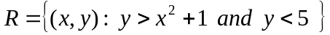
6. (a) Use figure below to calculate (i) MN (ii) MY

- the angel of elevation of the top of a house 24m high is observed from the
top and from the bottom of a vertical ladder, and found to be 45⁰ and 60⁰ respectively find the height of the ladder.
7. A boat sails 3.202x10⁶ dm from O to P on a bearing of 32⁰ s and then to Q on a
bearing W 50⁰S if OQ = 4x10⁶dm find (a) the distance from P to Q
(b) the bearing of O from Q
8. (a) If a = 3i+4j, B= 5i – 3j and c = 4i+3j
Find (i) V if V= a+b+c (ii) magnitude of V (iii) unit vector in the direction of V
(b) If
(i) Display the information on a Venn diagram
(ii) Give the values of n (A) and n(B).

9. (a) An area of 24.7cm² was plotted on a map of scale 1.50000. what is the
area in km² on the earths surface.
(b)

10. (a) A vag contains 3 black mables and 2 white mables, a mable is taken
from the box and then replaced. A second mable is chosen what is the probability that
- They are both black
- One is black and one is white
- The probabilities if the two mables are chosen without replacement
(b) Given that A = find |3A -2B + C|

SECTION B.
11. the following are the scores of 100 students in maths test
Length | 40 - 42 | 43 - 45 | 46 - 48 | 49 - 51 | 52 - 54 | 55 - 57 | 58 - 60
freq. | 4 | 9 | 13 | 20 | 34 | 18 | 2
(i) Calculate the mean of the distribution by using assumed mean.
(ii) Draw on ogive and use it to estimate the median
(iii)Draw histogram and use it to estimate the mode
12. (a) A slip sails due North from latitude 20⁰S for a distance of 1440km. find
latitude of the pint it reaches
(b) An aeroplane takes off from B(5⁰S, 33⁰E) to C(5⁰S,39⁰E) at a speed of
332km /L. if it leaves B at 3.00p,m at what time will it arrive at C airport? (Circumference of Earth =4 x 10⁴ km).
(c) A linear transformation T maps of paint (-1,0) onto (0,1) and the pint (0,-1)
onto (-1,0) find (i) the matrix T of transformation
(ii) The image of the pint (2,-1) under T

13. ABCD is a right triangular pyraund with base ABC which is an equilateral
triangle given that AB = BC= CA= 8m and DA = DB= DC=10m calculate
(i) The height of the pyraund
(ii) The angle BD makes with the plane ABC
(iii) The angle between the planes DAB and ABC

14. (a) A man requires 15 ments of chemical A and B respectively for his
garden . A liquid product contains 5 and 2 units of A and B respectively per jar. A dry product contains 1 and 4 units of A and B respectively per cartin. If a liquid product costs Tsh. 3000/= per jar and the dry product costs sh. 2000/= per carton how many of each should a person purchsase to minimize the cost and meet the requirement
(b) Use matrix increase method to calculate for X and y give that



